Day in the Life of the Hudson River 10/14/21
Hudson River at Newcomb, East Branch Savannah’s River at Wells, Schoharie Creek at Middleburgh
RIVER MILE: 310
Salt Front: ~ 49
Middleburgh Central- Mollie Burgett
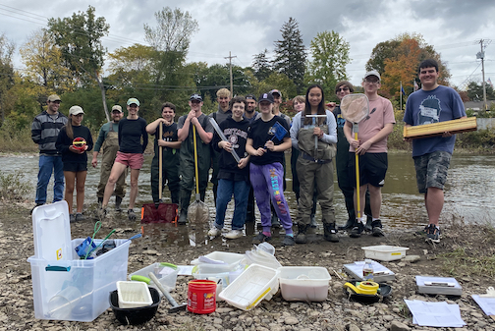
Doug Reed, HBRW
DEC Fisheries
14 students 12th grade, 4adults
Latitude 42.599635 N & Longitude – 74.337226 W
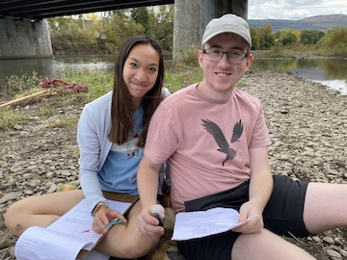
Location: Schoharie Creek, Mohawk Drainage, Middleburgh, Schoharie County, NY
Surrounding Land Use: 70% Forested, 30% Urban/Residential, 5% Industrial commercial, 45% Agricultural
Sampling Site: Creek access point is north of Timothy Murphy Park, Fishing access on northern side of the bridge.
Shoreline: Rocky beach area, covered with vegetation, storm drain outflow south of sampling ~50 ft
Water: 18 inches, calm
River Bottom: Rocky, small to medium cobbles
Plants in the water: no plants in the water area
*NR = Not read/recorded
ITEM | Time | Reading |  |  | Comments
Physical
Air Temperature | 11:00 AM | 22.3 º C |  | 71.6 º F
Wind Speed: | 11:00 AM | Anemometer  NR |  | Beaufort  1.75 | Direction  E
Weather today | 9:20 AM | 26-50% cloud cover |  | No rain
Weather the past 3 days: | Warm, sunny, and overcast, mid 70 partly sunny
Tides- NA | Time | Rising, Falling, Unchanged |  | Height (cm)
Above the head of tide
Current- NA | Time | Cm/sec | Knots | North/South | Ebb/Flood/Slack
 | 9:27 AM  9:30 AM  1:45 PM |  | 0.95  0.98  1.07
Water Temperature- | 9:30 AM | 16.5 º C |  | 61.7 º F
Turbidity- long site tube | 9:30 AM | 60 cm
Chemical

Salinity- | NA
DO – drop count Lamotte | Time | Temp | ppm DO | % saturation
 | 11:00 AM | 16.5 º C | 11 | 107%
pH – indicator solution | 9:45 AM | 7.6
Nitrates- | 11:00 AM  11:00 AM | 0.2 ppm  0.2 ppm
Biological
Fish | Number | Name | Length of longest | Notes
Local Electro shocking with the students in the creek | 1  1  3  44  31 | Bluegill sunfish  Northern Hogsucker  Central Stone Roller  Rainbow Darter  Greenside Darter | 3.0 cm  6.4 cm  6.1 cm  7.7 cm
Fish Totals | TOTAL: 80 | Diversity: 5
Macroinvertebrates | Number | Name | Length of longest
Kick Net  2 Total minutes of kicking | 56  4  1  3  4 | Mayflies Larvae  Stonefly larvae  Hellgrammite  Caddisfly Larvae  Aquatic worm
Macroinvertebrate Totals | TOTAL: 19 | Diversity: 6
Sediment Core | Time | Oxid Top | Grain Size | Other Features
No length recorded |  | NO | Rare: Gravel  Common: Mud | Rare: Shells, Living Vegetation  Common: Macros.
Observations

